DICE-VIC 19
2nd December, 2019
Kinnaird College for Women Lahore successfully organized its First DICE-VIC 2019 on 2nd December 2019. An Inter-Departmental Competition of Innovation Ideas at Kinnaird College for Women Lahore. All departments of Kinnaird College for Women Lahore participated
11 Innovative Prototype Projects were presented
- Peelo
- Lactono
- Dragon Balls
- Jamoloupe
- Breeze Veggie Punch
- Chia Waffles
- Aloe Bites
- Beetroot Mayonnaise and Sause
- Hordeum Bars
- Avena pasta
- Vegetable Snack Bar
16 Poster were presented at that event.
- Online Statistical Consultancy Service (OSCOS)
- Ecofriendly edible water balls from brown algae and calcium chloride to reduce plastic use
- Utilization of Mango seeds for the production of Biodegradable plastics using Glycerol as a plasticizer
- Plastic made from grapefruit peel and carbon dioxide
- Bar shampoos- another way to fight pollution
- Peel ECO
- The Extraction of Gold from E-waste
- Substituting vegetable oils used in toilet soap production with starch (corn and mango seeds).
- Fabrication of super hydrophobic nano textile via Green Nanotechnology
- Simple, Rapid, and Reliable Detection of Escherichia coli O26 Using Immunochromatography
- Nano-coating Hybrid Insecticidal and lizard Repellent Thermospray
- Do the great, use the waste
- Highway wind turbine
- Food Waste Reprocessing Alliance Project
- Coping with water scarcity through recycling and reuse
- The Green Tiffin
All groups of prototype displayed their projects on 2nd December but only 4 ideas from posters were presented.
Inauguration by Mr. Tariq Sarwar Awan: 1st Entrapenuar Food Technologist and Director All Pakistan Flour Mill Association
Dr Shahbaz Shamsi Director Quality Assurance Punjab HEC
Mrs Nayyar Rubab Senior Creative Manager Eye Network
Principal Dr Rukhsana David
Vice Principal Dr Nikhat Khan amongst others were delegates from industry, academia and USAID
Judges
Tariq Sarwar Awan
Dr Ijaz Director Food & Biotechnology Research Centre PCSIR Lahore
Mr Rana Awais Founder and Chairman National Alliance for Safe Food
Mr Asim Director Deacom
Dr Sanaullah HOD Food Science and Human Nutrition UVAS
Following are the winning teams of events
1st Position
- Peelo (Mahnoor Rizwan, Ayesha Khan, Anusheh Tufail)
- Plastic made from grapefruit peel and carbon dioxide (Fatima butt)
2nd Position
- Lactono (Iqra Elahi, Laiba Noor, Maira Nasir)

3rd Position
- Beetroot Mayonnaise & Sauce (Fajar Sawar, Gul-e-Jannat, Hajra Azeem)

News
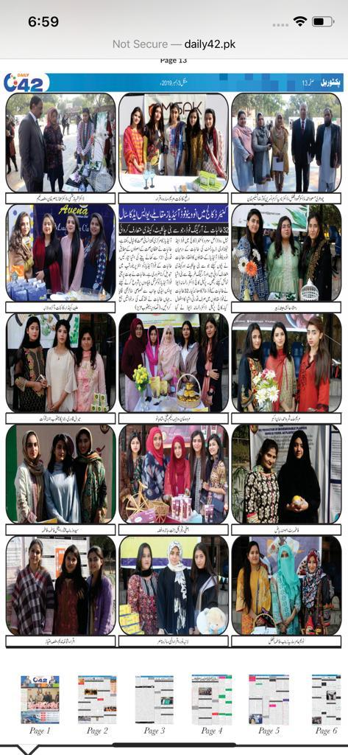
Here is the link for event coverage
https://drive.google.com/drive/folders/1gaJhXXMnNfPHZv6QGWcvr5-E8piLmKxi

